Flo Gray

Critical Analysis Of

Habin Kim’s

Work in Practice

This essay is an in depth exploration of the practice of Habin Kim, a sculptor who explores ideas of the subconscious revealed through materiality, the excess of control, the sensitivity of gesture and the wit and body language of material. Working with materials primarily of a fragile yet mutable state such as latex, resin and glue she approaches a near disconnection from material through the unavoidable abandon, the acceptance of allowing material to adopt a sudden realised form. This adoption is temporal, the artist wraps, stretches drapes material across chairs, poles, walls encouraging gravity to warp and disfigure on its own accord. This interplay between choice and chance, order and disorder overcomes composed forms and is rich in the artist’s idiosyncrasies as well as the environments inevitability. The artist’s persona feeds heavily into every aspect of the work but is not immediately perceivable. Habin’s written work, although a separate entity considered as a reflective process by the artist, reveals the shared subconscious between the artist and the sculpture.

What immediately drew me to Habin’s work was a kind of inaccessibility and a difficulty of perception that draws you in a spiral of desire to connect and decipher the intent and vulnerability of the artist. Having read Habin’s statement in conjunction with her work I feel almost a sense of resolve but with a hindrance of guilt for knowing the artist’s habitual methods practised as a form of therapy. Although this is not an uncommon phenomenon, particularly as a shedding process of the obsessive and repetitive behavioural constraints of those suffering from Obsessive Compulsive Disorder, there is the stigma thrust upon art and insanity as a collation. This inherent negative light is in fact contradicted in the art world as the traits of OCD such as repetition, regularity, pattern and order are admirable. Habin works obsessively with latex describing her process as repetitive, having made an excess of 30 sheets of latex, yet lengthy, but with the nature of latex having developed an acceptance to relieve control. Her piece titled ‘CTRL’ insists an order and pattern on four neatly folded pieces of latex, although the inconsistencies of the latex are palpable, the artists contradicts this with the acts of folding and ordering. ‘ I II II I’ are labelled below each folded sheet which further suggests the artist works systematically. With the knowledge that Habin in fact suffers from OCD it triggers a perception that perhaps this sequence is applied beyond the practice and in the everyday life of the artist. At a closer glance it is evident that the artist has burned the sheets of latex charring the material, an irreversible act. This then takes on darker connotations considering themes of death, burnt flesh and decomposition. You are left wondering if these forms are in fact found objects.

Cornelia Parker, a remarkably inventive sculptor and installation artist, urges these same inquisitions in works such as ‘Mass (Colder Darker Matter)’ and ‘Heart of Darkness’. Both these pieces show suspended fragments of charcoal that as a collective appear like a swarm of dark matter that either wants to absorb or exclude the viewer. Parkers titles in themselves are cold and disconnected, similarly to Habin’s title ‘CTRL’, however we are informed that the nature of Cornelia’s charred remains are in fact found objects taken from tragic incidents of runaway wildfires and church’s struck by lightning. These works are based on the tragedy of others where as Habin’s work is perhaps inner emotion and experience projected outward. Habin describes an ‘overwhelming force that dictates the beginnings and ends to my art works, a compulsion to free my body through creation. Each work I make is a journey of recovery, a passage through emotion starting with acceptance and ending with closure.’

Both Habin and Parker consider Weight, mass, density and volume and their interplay in space as a physical expression both obtaining a sense of energy and entropy in their works. In the essay ‘Improbus Materia: Maybe’ the art critic Bruce W. Ferguson expresses that “Parker reinstates the materials back in the contrary directions – a vice versa of expectations or even inevitability. Her work performs almost enchanted acts of material irony, in which the substances are themselves persuaded to make light of their own properties and inspire a reading opposite to everyday certainty. In fact, time and again they produce readings in which the viewer is reminded of the continuum of time and of context, and the mutability and immanence of both. Her artworks act, to use Roland Barthes’s useful semiotic term, as ‘shifters’- ambiguous hinges that open and close on differently embedded spaces.”.[1] This idea that Parker’s work is in a constant state of flux, shifting, is juxtaposed by the irreversible nature of a charred material. In this sense I feel both Habins ‘CTRL’ and Parker’s ‘Heart Of Darkness’ represent a significant end. The dance between passive and active material then reaches a harmony.

Another artist I would consider a significant parallel to Habin’s method in practice is the Infamous Yayoi Kusama. Yayoi Kusama channels her obsessive behaviours and tendencies into her work and perhaps this is more perceptive in the obtrusive repetition evolving sinuously throughout her body of work. Kusama is well recognised for her fixation with polkadots that have patterned almost every sculpture she has made to date. This internal sense of pull and push is evident in both Habin and kusama’s work however it is birthed in different forms, Kusama’s materialises in her polka dot motifs that encase oblong shapes or entire rooms where as Habin’s is less visually loud and more drained into the physical state of material. Habin elaborates upon her process: “In creating my latex sheets I work with liquids that can only be controlled to a certain point, after which I must release control for up to three weeks for the sheets to set. The results of the sheets are left up to serendipity. I have made over 30 different sheets now, and the process is gradually getting easier.” Her piece ‘F says I’m an anal expulsive’ does however take the latex rich in the angst of letting go of control, but visually far removed from the OCD’s ‘ideals’, and begins to reorganise and reinstate a fluid form into a pattern, an order. These choices demonstrate that push and pull of a desirable order that plays heavy on the artists mind. The title ‘F says I’m an anal expulsive’ indicates they want the viewer to be aware of the artists personality in question. Anal expulsive, a Freudian theory of psychosexual development, refers to a personality deficit that presents itself if a parent and child endure conflict at the ‘anal stage’, the stage of toilet training, which can result in a personality that is too disordered or too rigid. There is a wit and body language that feeds into this work that is realised through the title. The act of excretion seemingly imitated by the chairs and the latex flowing out of their hollow backs. These sensitive gestures laden with deeply personal inner conscious lead the material process to a fragile state heightened by the immersion of the material within the everyday chair.

Yayoi Kusama’s ‘Propagating Room’ also suggests an absence or a presence of the body and the artist’s subconscious. An everday scene, the interior of a home is lit up, ‘obliterated’, with 100s of multi-coloured dots. Once you enter the installation you enter the artist’s subconscious but far removed from the artist herself. Yayoi Kusama expresses “Artists do not usually express their own psychological complexes directly but I use my complexes and fears as subjects. I am terrified by the thought of something long and phallus entering me and that is why I make so many of them. The thought of continually eating something like macaroni, spat out by machinery fills me with fear and revulsion, so I make macaroni sculptures. I make them and make them and keep on making them until I burry myself in the process, I call this obliteration.”[2] In both Habins and Kusama’s work an everyday scene or object can inhabit an expression of their own human fragility.

One significant parallel in all of Habin’s work is the important relation between concept and the delicate human nature. Habin talks about the importance of honesty in her work and the integrity between the viewer and the artist, the barrier of honesty and façade. The artist Louise Bourgeois has a similar inclination to bare a truth in her work, she elaborates “Sculpture allows me to re-experience the fear [of my past], to give it a physicality so I am able to hack away at it. . . . Fear becomes a manageable reality. Sculpture allows me to re-experience the past, to see the past in its objective, realistic proportion.”[3] Bourgeious gives her memorys and emotions a physical presence and enabling her to relive them. The pressure tangible in Habin’s work reflects her past experiences, in her various statements Habin talks of a near suffocating strictness enforced in her upbringing when living in Korea and anxiety induced by a need to satisfy a strict regime. This frustration pours out of her work, physically and figuratively in her piece ‘F says I’m an Anal Expulsive’. Habin describes being ‘fixed in a world where emotions were weak, within a world where the balance between tension and pleasure was heavily tilted. Creating art and communicating in a visual language is the most freedom I experience, I rarely feel bounded by any protocols or limits to make-work in a certain way. Nothing is forced and nothing is unnatural.’ With both Habin and Bourgeious the work takes on a natural form, the haptic experience between the artist and the material transcends a pre perceived plan or notion for the work. A feeling a memory a fear become the material and take over the form.

Bourgeois’s ‘Femme Volage’- defined as fickle, capricious, reckless, appears as a delicate and fragile human character made up of small fragments of painted wood. Each fragment is dependent on another to stay upright like the fragile workings of a body or skeleton. Describing this bodice as ‘volage’ a kind of unpredictable persona you are able to see the alike of a person and a sculpture. Bourgeois spoke of making many figures like this as remembrances for those she’d lost or left behind describing them as ‘presences’. Habin’s sculptures where she wraps latex around poles encourage a human like presence to the work. The skin like quality of the latex and the stark pole legs are characterised by titles such as ‘splay me’, ‘legs wide open’ and ‘I like it’. The sexualisation of an inanimate object insights a removal of a person’s inner thoughts projected onto a thing rather than a being. We are invited as a viewer to sexually objectify an object which brings about an awkwardness in our awareness of sexual identity, we are considered as a site of seduction. This discomfort could be flippant and in fact the work enables an awareness of the absurdity of feminine ideals. In the piece ‘Le Regard’, by Bourgeois, what appears to be an erotic orifice could in fact be an entrance, a mind pit an excavate for emotion. It seems to comment on access between the artist and the viewer and draws out a kind of brutal honesty that is prominent throughout Habin’s work but particularly in her pieces ‘splay me’ and ‘legs wide open’. There is a curious characteristic of black humour interlaced with a questioning of sexual identity and the absurdity of life throughout Habin’s practice. Titles are significant in dissecting the work. Instances such as ‘Splayed’, ‘Ctrl’ and the use of the abbreviations which we would associate with a keyboard insinuates a kind of automated control. This automated control is immediately an intimation of her bond and experience with control. Her title ‘splayed’ defined as ‘spreading of the limbs’ has violent connotations but the colloquial sounding nature of the word almost neutralises the discomfort of the meaning.

Having had a brief fascination with the work of Eva Hesse, seeing Habin’s work immediately springs to mind the concept of the ‘anti form’ and similar paths of materiality to that of Hesse. Eva Hesse is known for her works ability to inspire a wide range of interpretations and associations whilst also resisting them which resulted from her desire to create ‘non art’. Her work acts as a response to minimalism however it attempts to overcome composed forms and serial systems. Material capability as the aesthetic and the belief that a material cannot be reduced to one state or characteristic plays heavily throughout Hesse’s career and these same principles are evident in Habin’s practice. The sheer physicality of Hesse’s work heightens the sensuality of her work and expands the Sensory perception increasing contact with the self, artist or outside world. Habin’s ‘Hung’ piece appears suspended in mid-air, a kind of chaotic yet ordered drawing using latex and rope. It rests on the borderline of transient and permanent as the work occupies the space but does not fill it. Gravity pulls and strains at the weight, mass and fragility of the sculpture but its element of chance and impreciseness give the object fleeting form. Eva Hesse’s experimentation with rope and latex in her ‘untitled’ work equally can be considered to be formless. The inescapable chaos of her “untitled” rope piece yet an equally embodying sense of order eliminates referents. There is however a powerful sensual intensity shaped by the immediate presence and the duration of the piece. In the rope piece gravity becomes as important as space and therefore it becomes impossible to project forms in advance. It has no clear front, back, inside or outside and appears to hover between something and nothing, resting on the borderline of not coming together. Both Habin and Hesse use a combination of highly sensuous textures and allow forms to swell, lean, sag or lie equates an awareness of our own bodies relating to the shapes and the assumed positions. ‘Hung’ and ‘untitled’ rope piece are suggestive of human insides appearing like a collection of human innards, spilled and draped into an open space. However Habin’s choice of title leans towards an even darker subject matter, the hanging of a body, notably larger loops and trails of blood like thread implicate this darker narrative.

‘Women is a Tease’ by Habin, likewise appears to deflect a carnal subject matter or personal desire upon the material. The material has a new found narrative. Although Habin and Hesse’s work shares many of the same aesthetics and a focus on process and materiality the titles Habin cherry- picks exudes sexuality. Habin’s obsessive use of the body can be associated with a clarification of the mind, a sense of conscious freedom. Freud wrote that “the artist sublimates less successfully than others, being more of a child, less willing to sacrifice those pleasures”, and declared a connection between manual work and repressive sublimation, “a source of libidinal satisfaction when selected by free choice.”[4] What could be referred to as an infantile sexuality innate in Habin’s work could explain the combination of obsessive repetition combined with a private fetishism led her work to existential humour and eroticism. Therefore Habin’s work is highly personal and the notable vulnerability intrinsic to her work and the repetition could be seen as a guard against her own vulnerability. The act of repetition feels safe but the outcome could be highly unexpected.

Although Habin’s work so far is progressive and her conceptual sense of the work and its effect on the audience are highly attuned, a medium Habin has not delved in, yet shown a great fascination towards is performance art. In her statement she describes an overpowering fear of dishonesty that she feels she would project during a performance but a strong inclination to try it. I suggest building up to a performance piece and even if her performance piece begins with the notes of dishonesty as long as she can accept a journey towards an honest performance. It appears she is looking for a freedom in the form of art that ‘has no bounds, physically and mentally’. I agree that performance art can be a true example of freedom but that one can never be free from the viewer, the effect of the viewer in response to an artist’s process of reaction and their way of thinking is completely unavoidable and perhaps performance art borders between entirely reliant on the viewer or a complete subject of freedom. This I feel is something Habin is crying out to experience for herself and definitely should do.

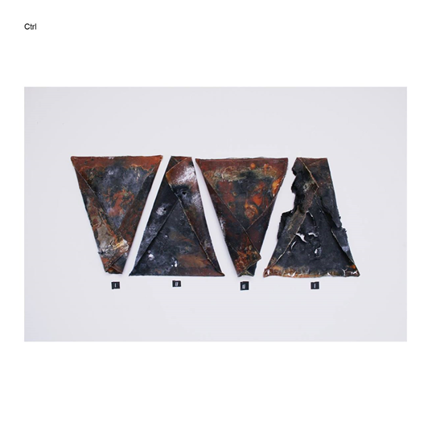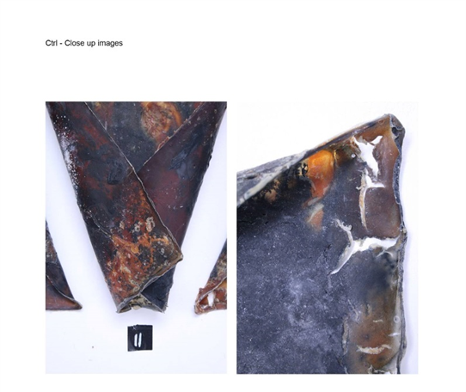

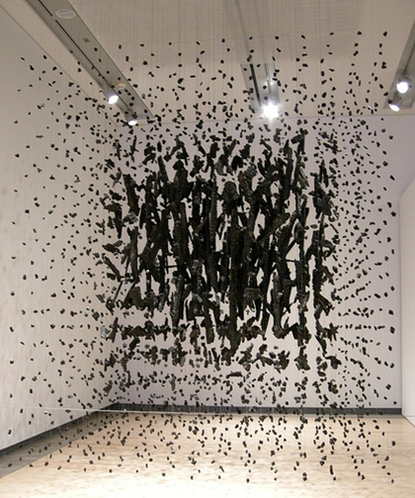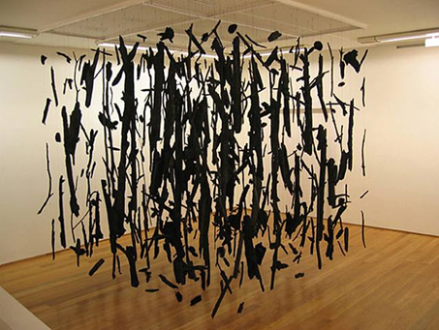

Heart Of Darkness, 2004, Cornelia Parker Mass (Colder Darker Matter), 1997

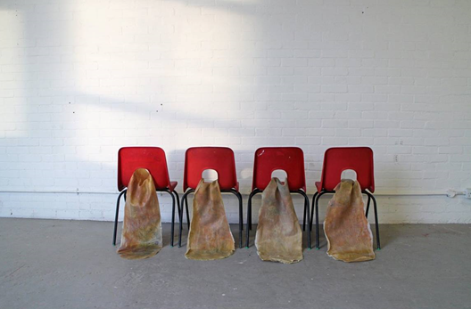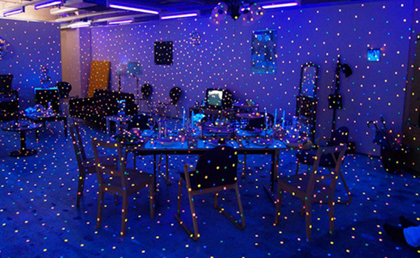‘F says I am an anal expulsive’, 2015, Habin Kim ‘Propogating Room’, Yayoi Kusama

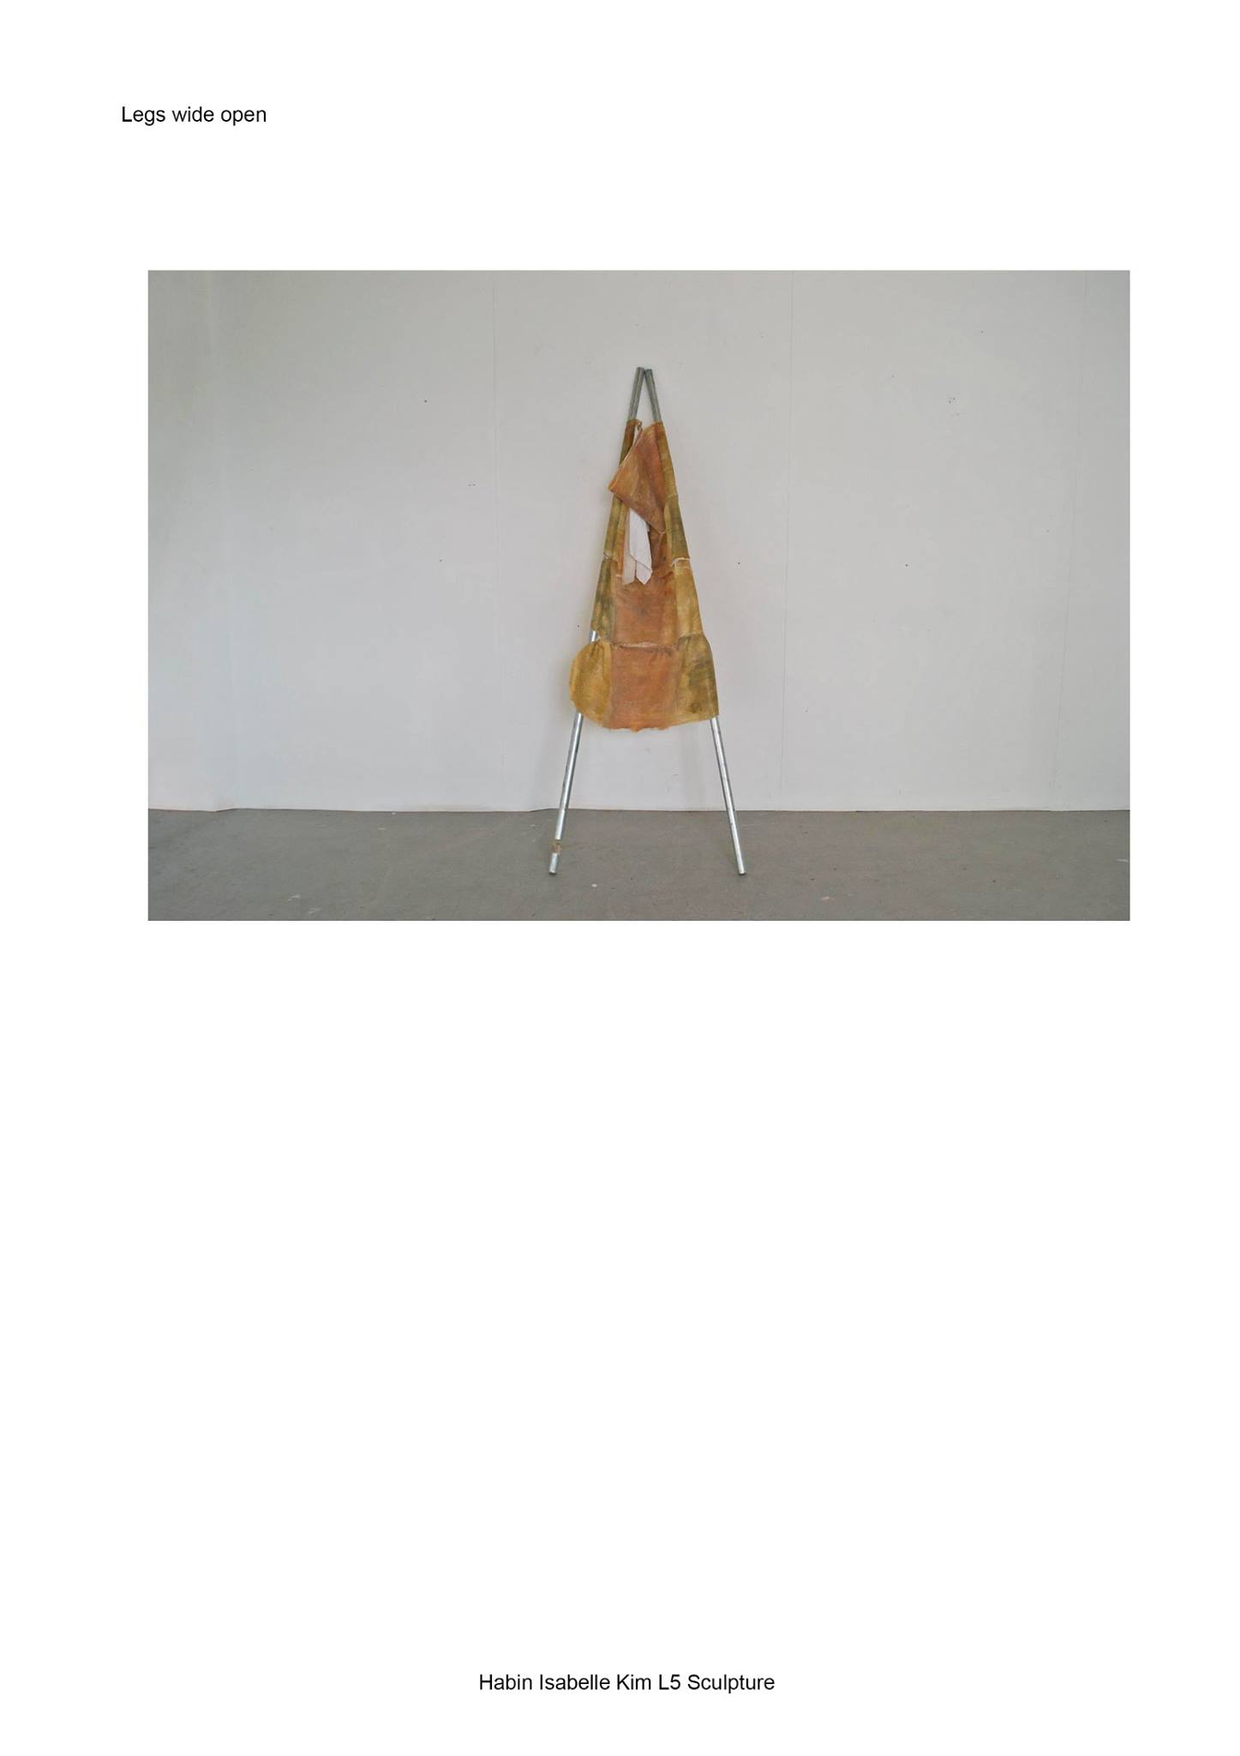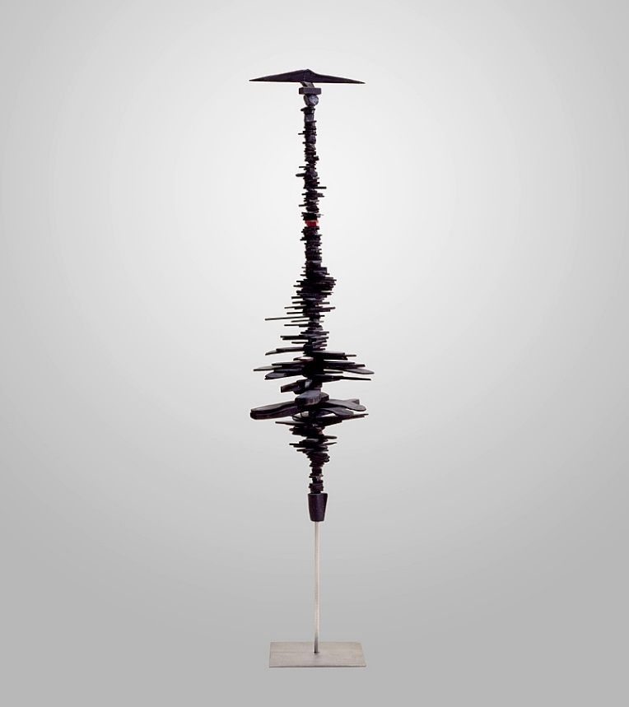

Femme Volage, Louise Bourgeois

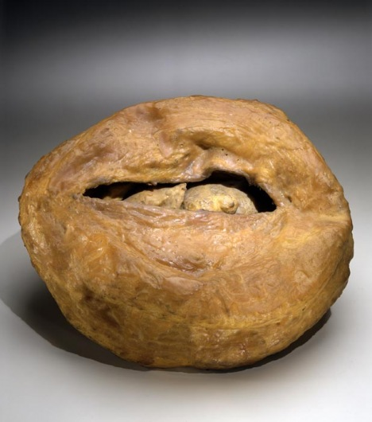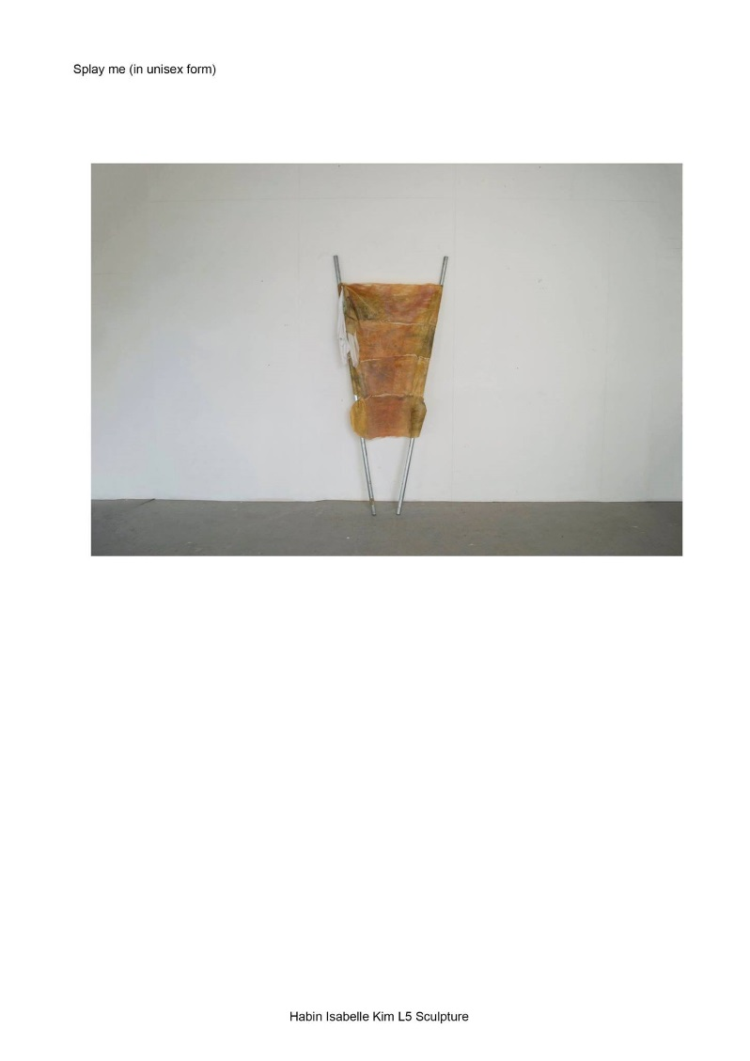

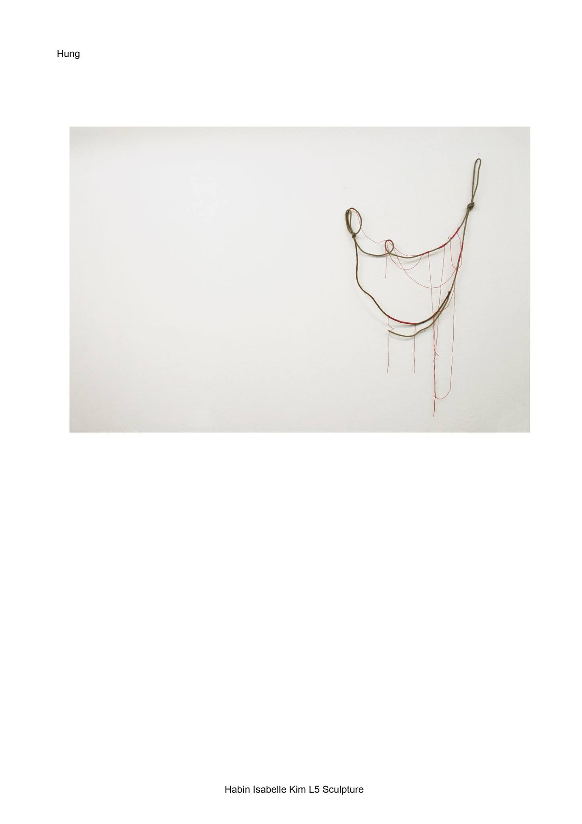

Le Regard, Louise Bourgeois

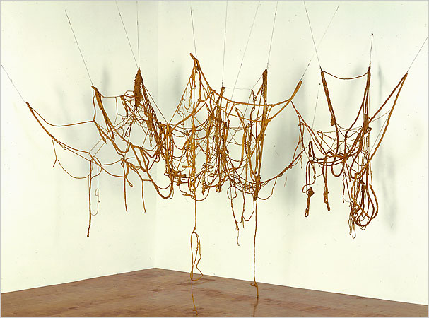

‘Untitled’ rope piece, Eva Hesse

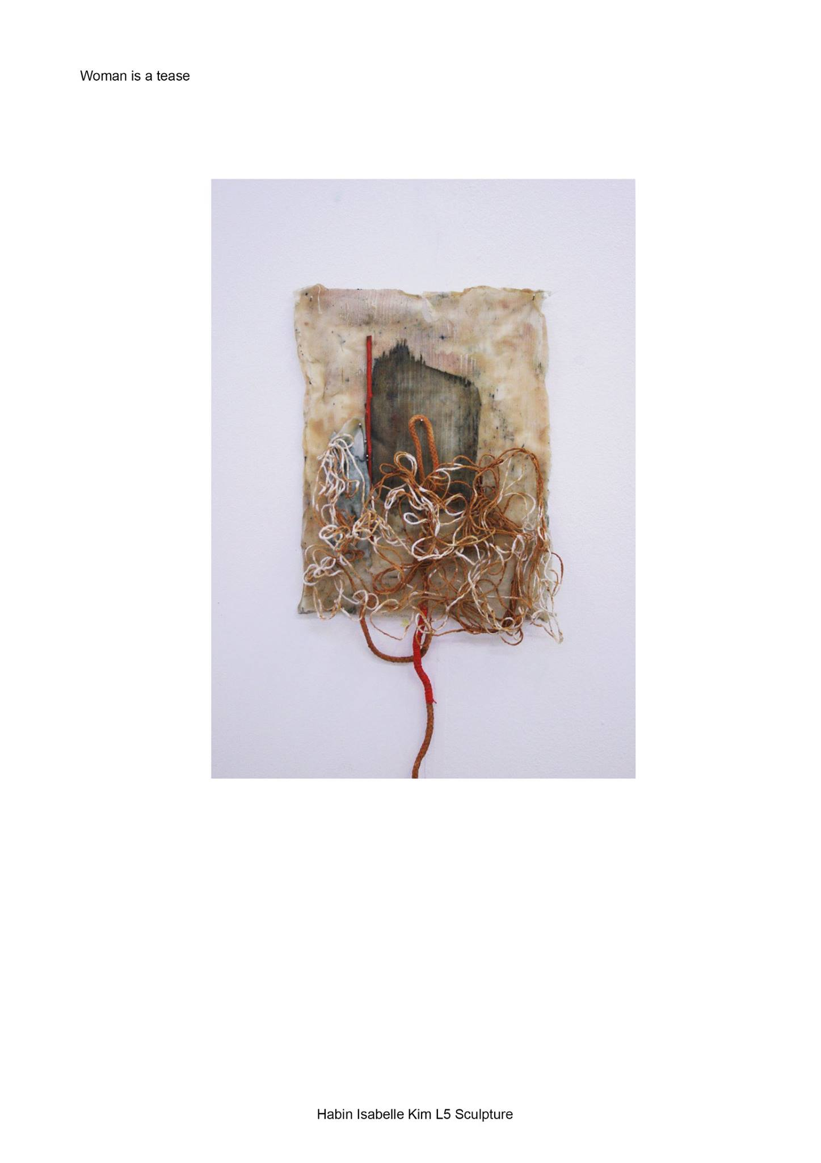

Bibliography

Books :

Lippard. Lucy, Eva Hesse, New York University Press, 1976, pg. 172-188

Sussman. Elisabeth, Eva Hesse, Yale University Press, 2002, pg. 17-22, 90-92,272-274, 252

Crone. Bourgeois, Louise, Prestel

Iwona Blazwick. Parker, Cornelia, Thames and Hudson

Websites:

<http://scholarship.claremont.edu/cgi/viewcontent.cgi?article=1569&context=scripps_theses>

<http://www.guggenheim.org/new-york/collections/collection-online/artwork/643>

<http://thecreatorsproject.vice.com/en_uk/blog/original-creators-the-princess-of-polka-dots-yayoi-kusama>

<https://en.wikipedia.org/wiki/Anal_stage>

<http://www.louiseandmaurice.com/#!MUSING-The-Liberation-of-Louise-Bourgeois/cmbz/55295d830cf2aa18119c6a31>

1. Cornelia Parker
2.
3.
4.